III Short introduction to the peritoneum

The abdomen contains the peritoneal cavity (abdominal cavity, peritoneal sac or greater sac), a so-called serous cavity containing a tiny amount of serous fluid. Other examples of serous cavities are the pleural cavity (around the lungs) and the pericardial cavity (around the heart). The peritoneal cavity is lined by a membrane called the peritoneum. The visceral peritoneum (surrounding organs or viscera like the liver, spleen, stomach) is called visceral peritoneum (indicated as an orange line in Figure 3C,D), whereas the part that covers the abdominal walls is called parietal peritoneum (indicated in blue in Figure 3C,D). During this session you will study the location of the peritoneum itself and the position of the abdominal organs in relation to the peritoneum.
Vertebrates (including humans) essentially have the same basic body plan. In early embryonic stages, they are bilaterally symmetrical – dividing them along the sagittal plane results in mirror-image left and right halves. With gastrulation, the left and right sides of the embryo start to express different molecules. At later developmental stages, organ growth results in their asymmetric spatial arrangement, and even though we still look more or less symmetric on the surface (two eyes and ears, two arms and legs), the inner symmetry is less well maintained. This is very obvious in the abdominal cavity as shown in schematic overviews at different developmental stages with increasing asymmetry (Figure 3). The transversal sections are taken at the level of liver and stomach (above the umbilicus = navel).
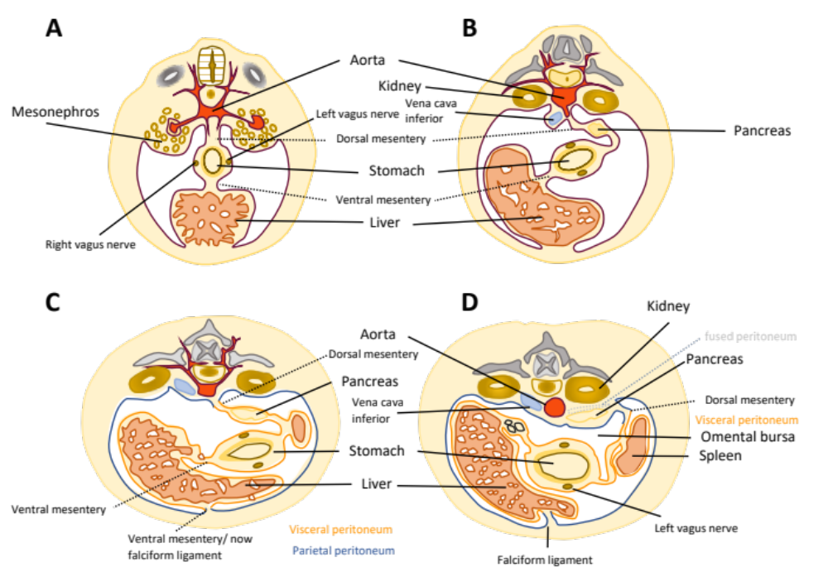

Figure 3. Development of asymmetry in the abdomen. Panel A: Bilateral symmetry. The mesonephros will later be replaced by the kidney. The future liver has a broad attachment to the ventral body wall – the ventral mesentery. The stomach is attached to both liver (ventral mesentery) and the dorsal body wall (dorsal mesentery). Panel B: Due to growth of the liver and the intestines, the organs are displaced from their original straight symmetrical position in the midline. The liver now takes up more space on the right side of the body. In the dorsal mesentery, the pancreas becomes visible. Panel C: only a small ligament remains of the ventral mesentery connecting the liver to the ventral body wall – the falciform ligament (from Latin falx = sickle - sickle-shaped). The spleen develops. The blue and orange lines indicate the parietal and peritoneum, respectively. The parietal peritoneum lines the walls of the abdomen. The visceral peritoneum covers the organs. Pancreas, spleen, stomach and liver are completely surrounded by visceral peritoneum – they lie within the peritoneum and are therefore called intraperitoneal. Organs that are attached to the body wall or lie behind the parietal peritoneum are called retroperitoneal (e.g. kidneys, aorta, vena cava inferior). Panel D: Through the growth of the intestinal organs, the pancreas has attached to the dorsal body wall and lies now in a retroperitoneal position. The pancreas is therefore called secondarily retroperitoneal, because originally, it was intraperitoneal (Panel C). In addition, a pocket has formed behind the liver, the omental bursa. S.E.Köhler, 2021

Below, you see two schematic drawings (Figure 4) showing transverse sections of the intestine. Left panel: retroperitoneal part of the colon, only partially covered by peritoneum; right panel: intraperitoneal part of the small intestine, completely surrounded by visceral peritoneum and attached to the body wall by the mesentery.

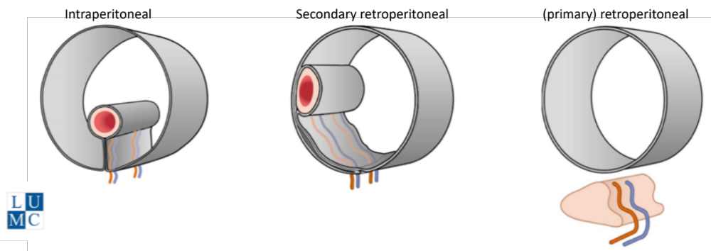

Figure 4. Positions of organs relative to the peritoneum. From left to right: intraperitoneal organs (e.g. jejunum, ileum), secondarily retroperitoneal organs (e.g. ascending and descending colon) and primarily retroperitoneal organs (e.g. kidneys). "Leiden - Drawing Scheme Three locations of organs relative to the peritoneum by Ron Slagter and O. Paul Gobée, LUMC, license: CC BY-NC-SA.

Look up the meaning of the words parietal and visceral and write down useful definitions. Also look up their etymology. You already came across these terms during the heart and lung sessions.
Parietal:

Visceral:

The omental bursa (seen in Figure 2D) is also called the lesser sac and lies behind the stomach and in front of the pancreas. The bursa is still connected to the abdominal cavity, also known as the greater sac or peritoneal cavity. The connection is a small opening (the epiploic foramen or foramen of Winslow), which can be found close to the liver. You can explore it during your visit to the dissection hall.

