II. Identification and topography of abdominal organs (model)

The location of anatomical organs can be described in several ways (see Figure, left and right panel) using anatomical regions. The location of organs in living bodies can change, depending on, for example, posture and respiration.
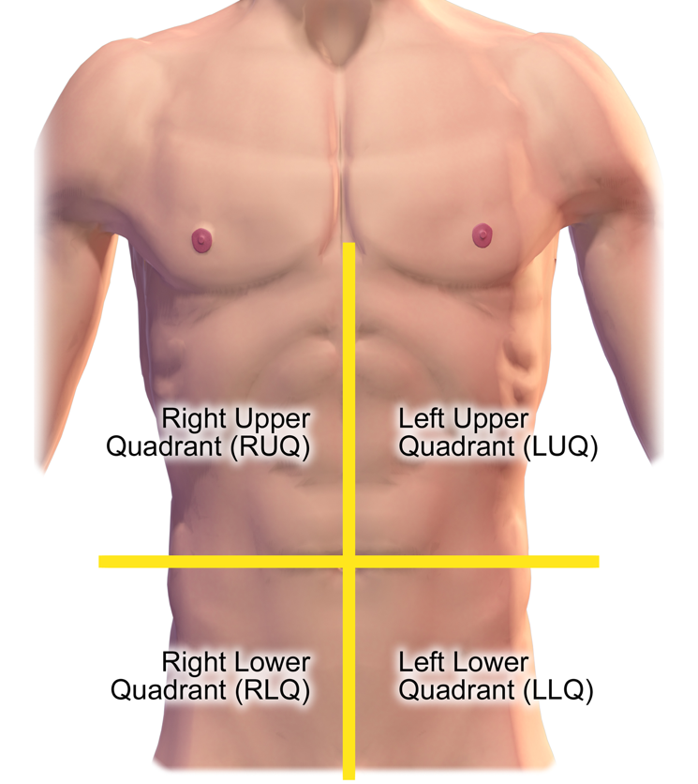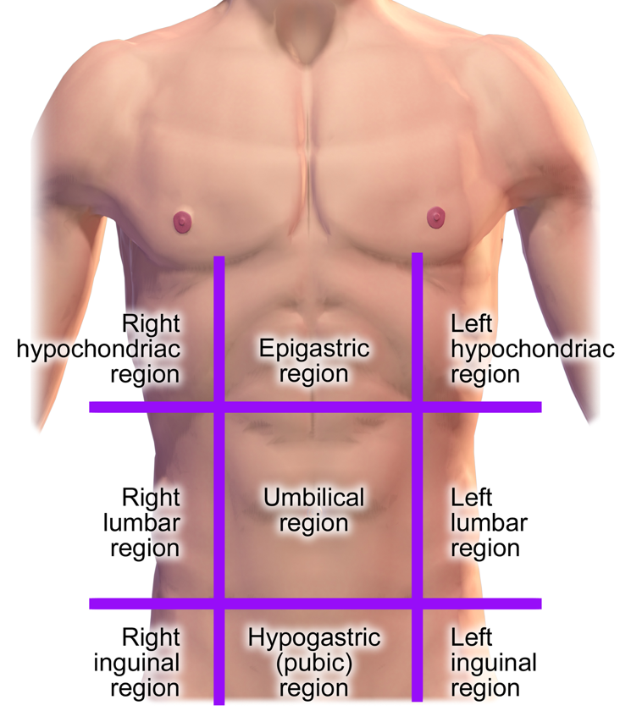

Figure 1 A: Anterior view of the abdomen with the abdominopelvic quadrants indicated. Medical gallery of Blausen Medical 2014., WikiJournal of Medicine 1 (2): 10. DOI:10.15347/wjm/2014.010. ISSN 2002-4436. Fig. 0005.

1B: Anterior view of the abdomen with the abdominopelvic regions indicated. "Blausen 0006 - Abdominopelvic regions - English labels " by Blausen.com staff (2014), license: CC BY. https://en.wikiversity.org/wiki/WikiJournal_of_Medicine/Medical_gallery_of_Blausen_Medical_2014

The abdomen can be divided into quadrants by two lines, that both pass the umbilicus (navel): the vertical median line and the horizontal line = umbilical plane. This division into quadrants is mostly used in general clinical descriptions (see Figures 1A and 2B).

Alternatively, the abdomen can be divided into nine abdominopelvic regions by four lines. The upper horizontal line, running through the most caudal points of the costal arch (costa = rib), indicates the subcostal plane (plane below the ribs). The lower horizontal line, at the top of the anterior pelvis (hip bone, ore more precisely: anterior superior iliac spine ASIS – the ilium is part of the hip bone), is called the interspinal line, indicating the interspinal plane. The two vertical lines, through the middle of both claviculae (collar bones), are the midclavicular lines (see Figures 1B, 2A).

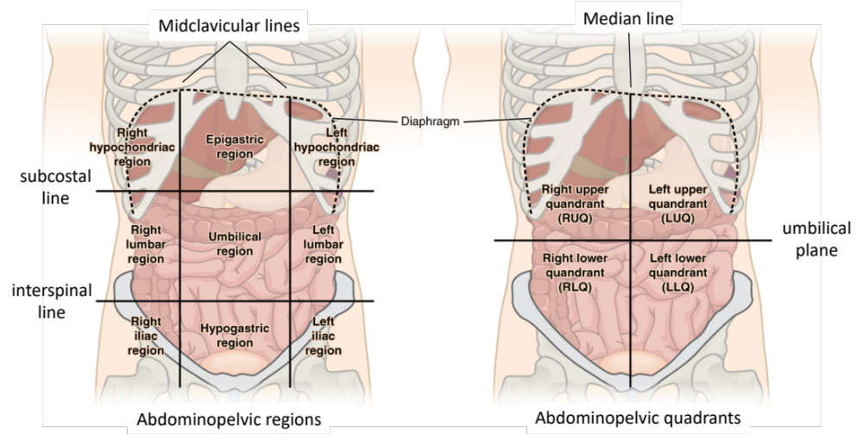
Figure 2A: Abdominopelvic regions and B) quadrants. Adapted from: " http://cnx.org/contents/17e4eea8-a005-45af-b835-f756a014cd48@3."

Study the position of the abdominal and pelvic organs.

The epigastric region lies above the stomach (epi – Greek: on, upon; gastro – Greek: stomach). The hypochondriac regions are below the cartilage (hypo – Greek: below, chondros – Greek: cartilage, in this case of the ribs/sternum). The term hypochondriac is nowadays also used to describe a person who suffers from imagined diseases. In ancient Greece, it was believed that the viscera of the hypochondriac region (liver, spleen and gallbladder) were the seat of melancholy, and the source of vapors that caused feelings of depression and morbid melancholy. Later, it was thought that this was also associated with physical symptoms and pain. After old medical beliefs disappeared, the term hypochondriac then remained to describe persons with groundless fears about their health.
The lumbar regions are at the level of the lumbar vertebrae (lumbaris – Latin: loins).

