Anatomy on the table - Stomach
O.P. Gobée, Leiden University Medical Center, Netherlands. Originally created for MOOC 'Anatomy of the Abdomen and Pelvis; a journey from basis to clinic'. Slightly revised for separate publication Aug. 2021
MOOC: https://www.youtube.com/playlist?list=PLzugOrS2Z8opb0FR1eJMVcy8_p-wRMPET
In this reader we will study the stomach in more detail. To orient yourself we first show the stomach still in place in the body in the first dissection picture (fig. 1).
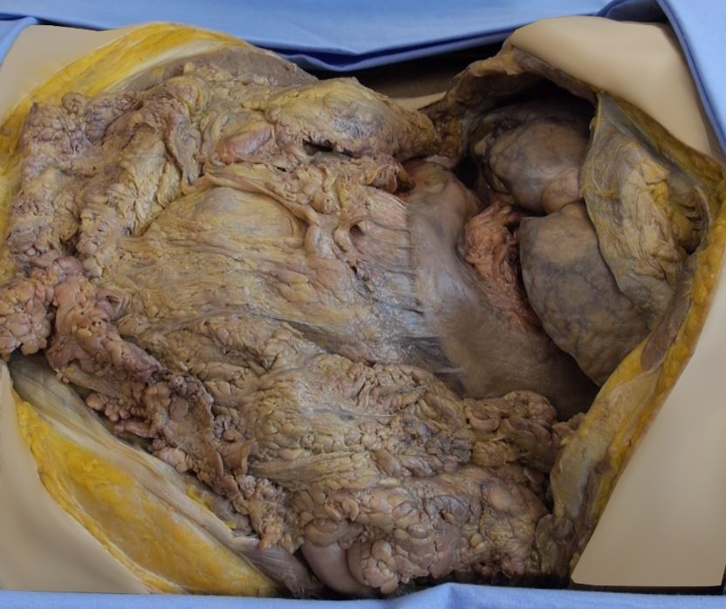

Figure 1: Stomach in the body
The stomach is partially covered by the liver and by the rib cage and partially protrudes inferiorly of those.
In the next picture (fig. 2), we have taken the stomach out of the body and placed it on a table. You can see the entrance of the oesophagus in the stomach and the exit of the stomach where it connects to the duodenum. Note that the stomach has a balloon or dome shape superiorly, and tapers to a funnel shape inferiorly. At the junction of the stomach and the oesophagus is a notch between the left side of the oesophagus and the stomach, called the cardial notch, or the angle of His.
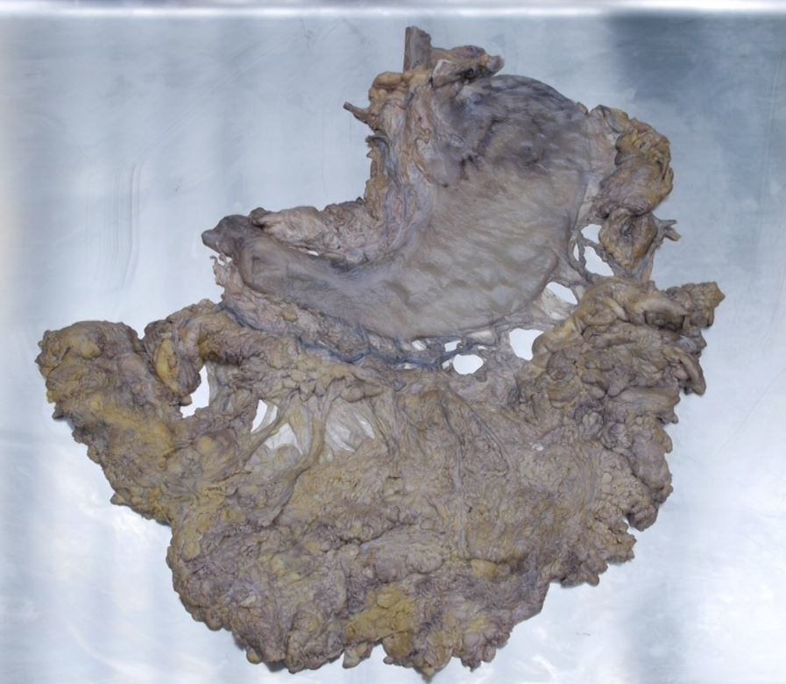

Figure 2: Closed stomach with greater omentum, taken out of the body,
The stomach can be divided into a number of parts.
The part of the stomach directly adjacent to the oesophageal opening is called the cardia. It derives its name from the fact that it is the part of the stomach closest to the heart. The heart is named ‘cor’ in Latin. Remember also that a heart doctor is called a cardiologist.
The dome shaped part of the stomach is called the fundus. By definition, it is the part of the stomach superior to a horizontal line that one may draw in the mind through the oesophageal opening. The fundus lies against the diaphragm.
The main part of the stomach is called the corpus, which is Latin for ‘body’. It is the part of the stomach between the fundus and the antrum.
The antrum, or with its full name the pyloric antrum, is the wider part of the funnel shaped outflow tract of the stomach.
Finally, the pylorus is the sphincter that regulates the outflow of chyme from the stomach. It is always well recognizable on the outside of the stomach as a firm bump. The stomach also has two curves: the outer, larger curve is called the greater curvature, whilst the inner, smaller curve is called the lesser curvature.
Have you found all parts of the stomach? If not so, please look for some more pictures. It’s just a matter of naming the different parts.
The next thing that catches the eye is the greater omentum that normally hangs down from the greater curvature of the stomach. It has been taken out of the body here together with the stomach.
Now let’s have a look at the blood vessels of the stomach. In the next dissection pictures you can see the blood supply to the stomach.
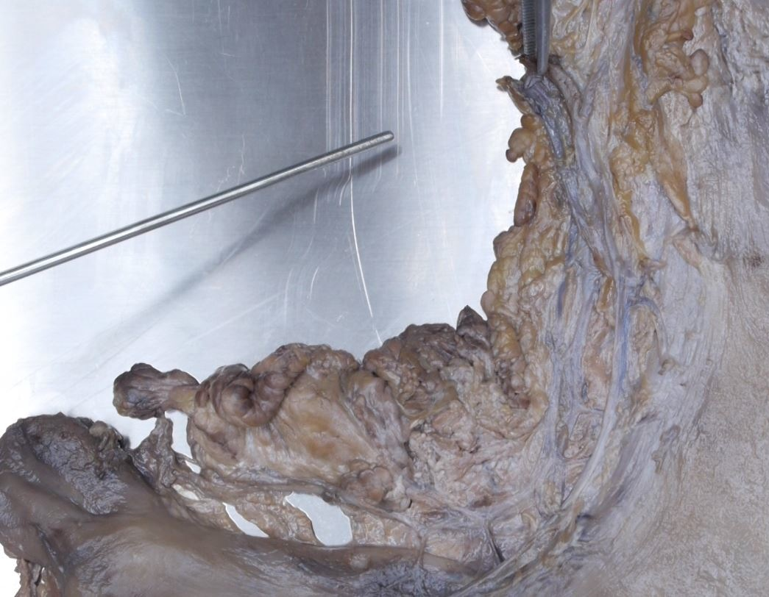

Figure 3: Left and right gastric artery and vein
Along the lesser curvature are the left gastric artery and the right gastric artery (figure 3). They are continuous with each other. Parallel with it are a right and left gastric vein.
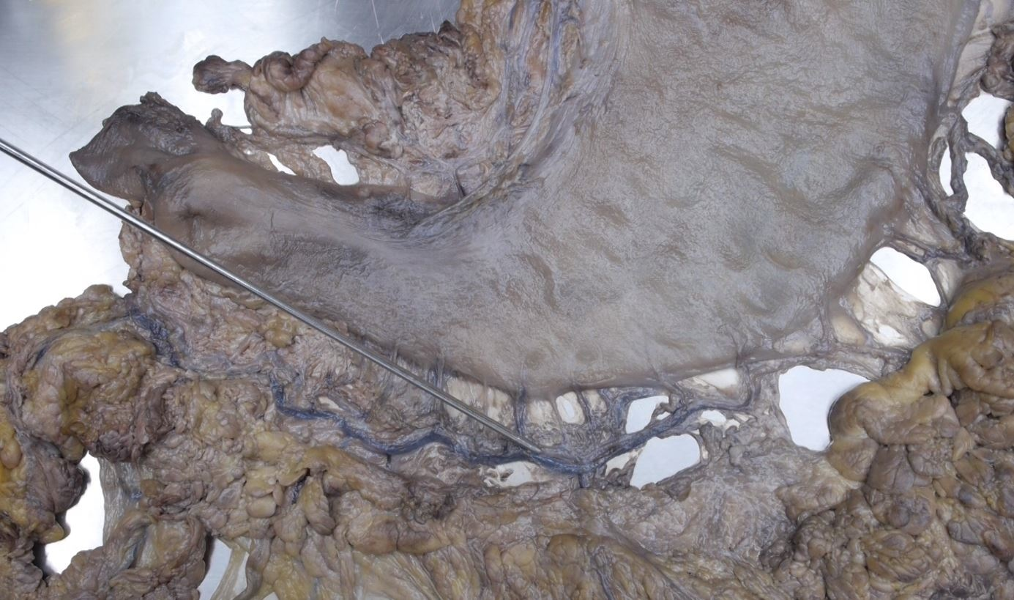

Figure 4 Right Gastroomental artery and vein
Along the greater curvature is a similar configuration. Here are a left and a right gastroomental artery that may be continuous with each other (fig. 4). They lie a few centimers from the stomach, embedded in the fat of the greater omentum. Again there have parallel, similarly named veins.
The configuration with left and right arteries that are continuous with each other and with arteries both at the lesser and at the greater curvature, causes the stomach to be very well vascularized. This allows surgeons to remove a part of the stomach whilst the remainder mostly is still well vascularized. The left and right gastroomental arteries however may not be connected, as can be seen in this specimen. Then there is a so-called ‘watershed area’ between them, that is somewhat less abundantly supplied. Near the fundic part of the stomach are even more vessels, the so-called short gastric arteries and veins.
At the oesophageal side we find the lower oesophageal sphincter, a slight thickening of the circular muscle layer. At the duodenal side we find the pylorus, a thickening of the muscular wall of the stomach.

Photographs of other stomach specimens
The interior of the stomach is shown in a different specimen (figure 5). You can clearly see the gastric folds or ‘rugae’. Along the lesser curvature are a couple of parallel gastric folds, together forming the so-called gastric canal. Small amounts of fluid, as the saliva we swallow continuously unnoticed, can easily run along this passage way.
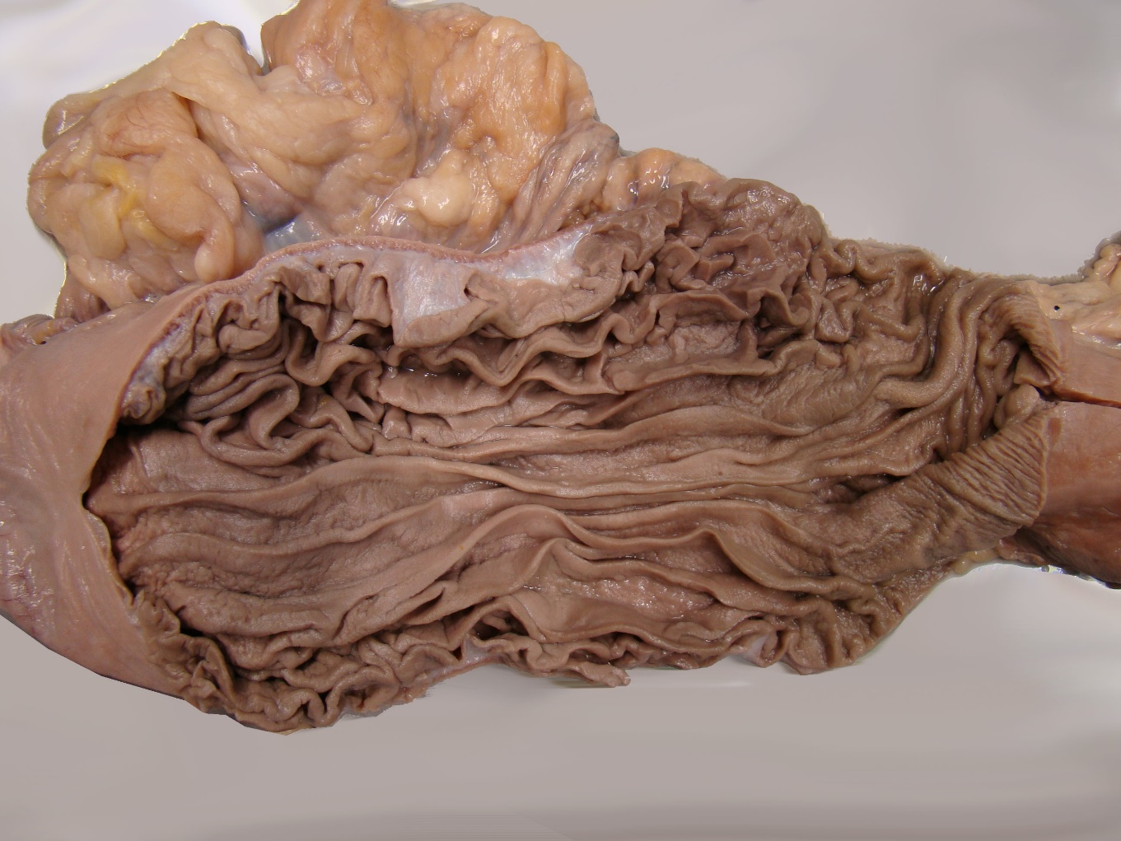

Figure 5. Gastric canal
Finally, seeing these specimens directly after each other, illustrates how much variation there may be in the size of the stomach. People don’t only vary in their looks on the outside, but some extent also on their insides!

License:
Copyright: Dept. of Anatomy & Embryology, Leiden University Medical Center, Netherlands
This work is licensed under a Creative Commons Attribution-NonCommercial-ShareAlike 4.0 International license (CC-BY-NC-SA).


