Anatomy on the table - The small intestines
O.P. Gobée, Leiden University Medical Center, Netherlands. Originally created for MOOC 'Anatomy of the Abdomen and Pelvis; a journey from basis to clinic'. Slightly revised for separate publication Aug. 2021
MOOC: https://www.youtube.com/playlist?list=PLzugOrS2Z8opb0FR1eJMVcy8_p-wRMPET

In this reader we will talk about the small intestines in more detail. To orient yourself we first show you a dissection picture of the small intestines, still in place in the body (fig.1).
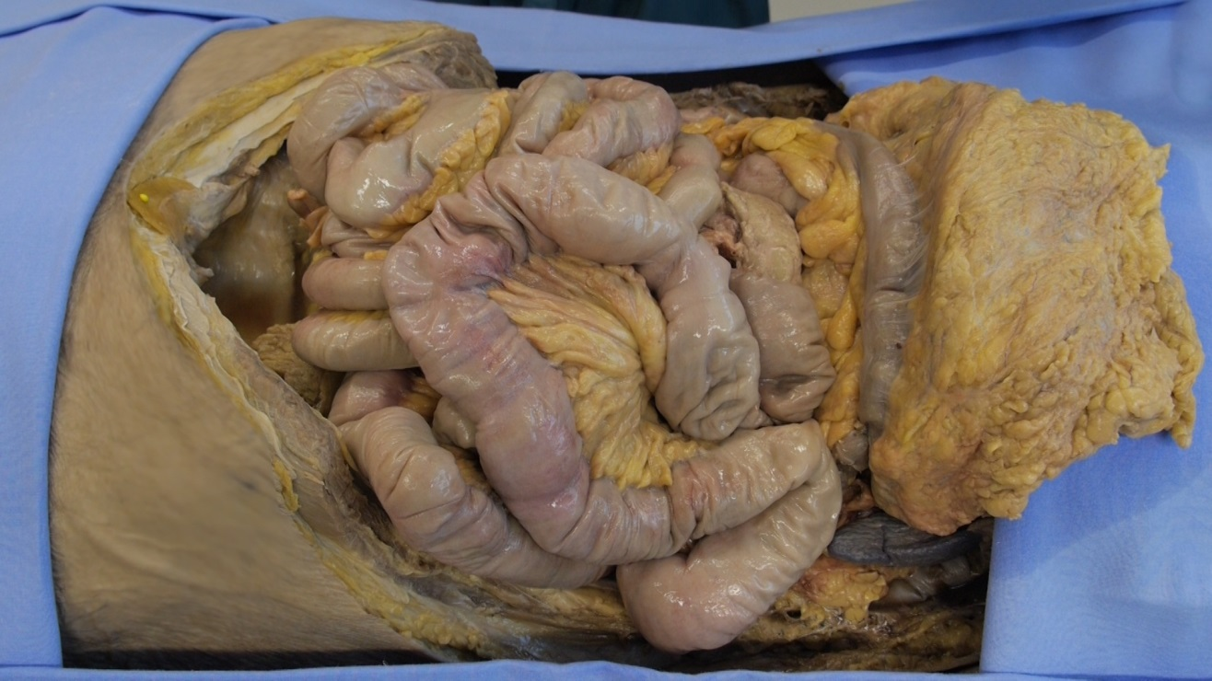

Figure 1: Small intestine in the body
The small intestines consist of the duodenum, jejunum and ileum.
Let's first focus on the duodenum.
Figure 2 shows the duodenum in the body. It starts just distal of the pylorus, the sphincter of the stomach, as you learned last week! You see the duodenum has a C-shape. It curves around the head of the pancreas, but that is difficultly visible in this specimen.
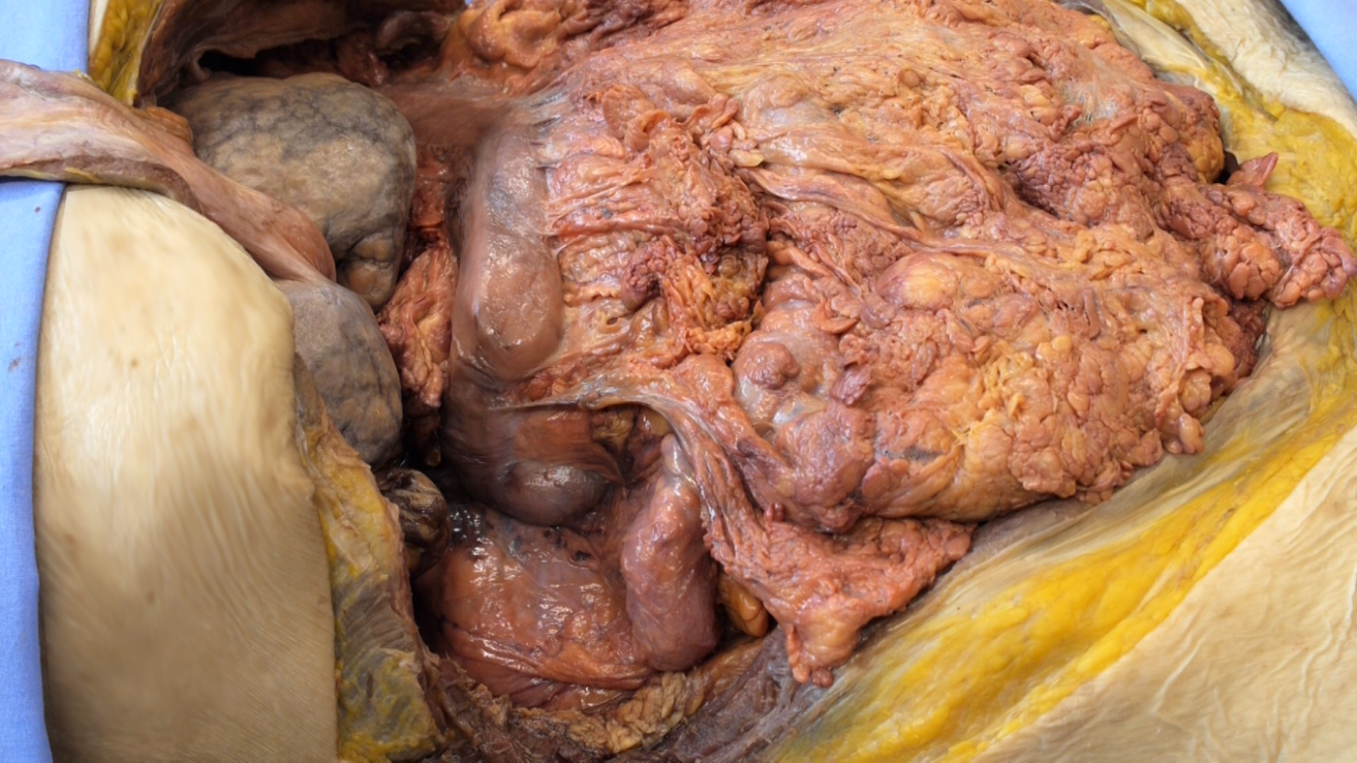

Figure 2: Duodenum viewed from the right
The duodenum is adhered to the back wall of the abdomen. It is crossed by the transverse colon. Figure 3 shows this, with the overlying transverse colon and the rest of the intestines moved a bit aside. The duodenum ends with a somewhat sharp bend at the duodenojejunal flexure, that is also called the point of Treitz.
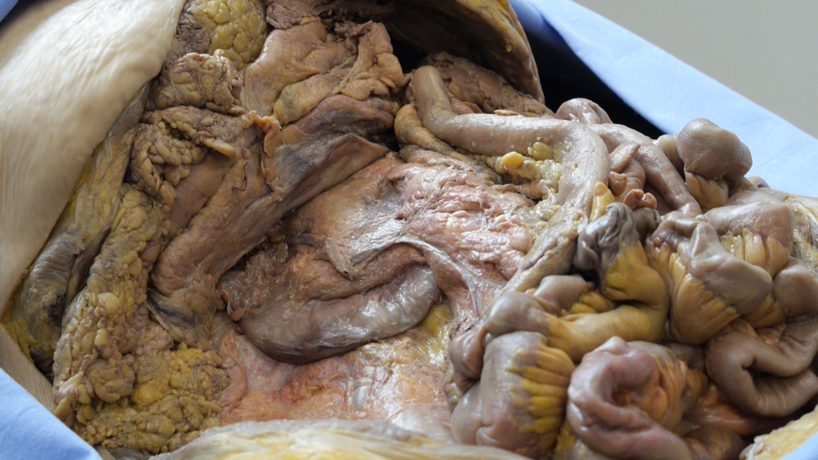

Figure 3. Duodenum with the overlying intestines moved aside
Now the duodenum is shown, extracted from the body (figure 4 - different specimen). We again clearly see its C-shape and that it curves around the head of the pancreas. The slab of fat contains the superior mesenteric artery and vein, that cross over the inferior part of the duodenum. Note the probe entering the bile duct.
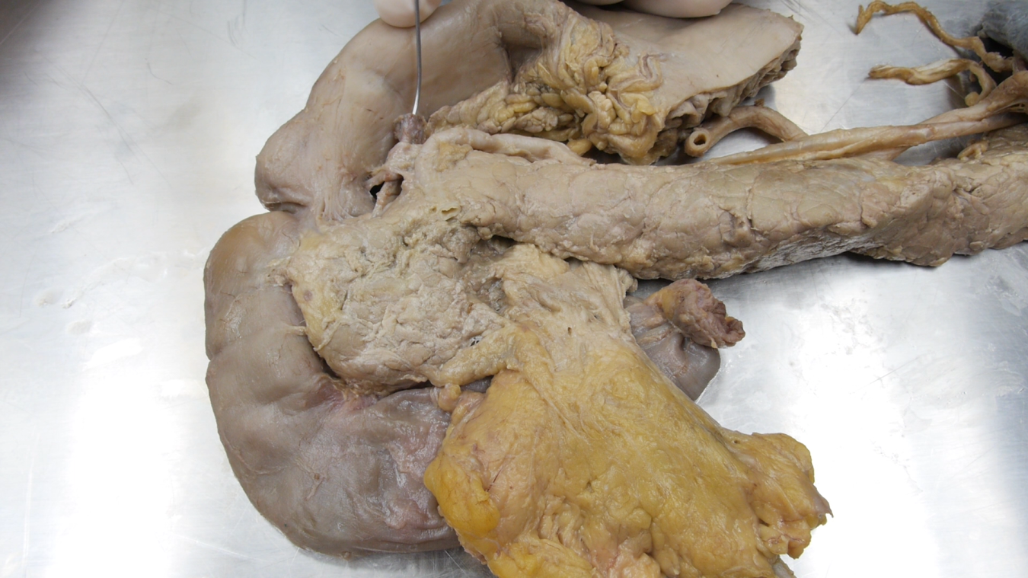

Figure 4: Duodenum and pancreas.
The duodenum can be divided into four parts: the superior part, the descending part, the horizontal or inferior part and the ascending part. Look them up if you’re uncertain which part is which!
The first two centimeters of the superior part is called the ampulla duodeni or bulbus duodeni. It is mobile and intraperitoneal, in contrast to the rest of the duodenum, that is fixed secondary retroperitoneal. You can easily imagine that, coming from the stomach which is intraperitoneal and mobile, this very beginning of the duodenum is the same and also not yet adhered.
Note: 'secondary retroperitoneal' means that originally in the embryological development this structure was intraperitoneal and mobile, but later it has adhered to the posterior abdominal wall.
The ampulla/bulbus duodeni is an important location as most peptic ulcers occur here. This is not strange, as this is the first place where the acid contents of the stomach reach the duodenum. The duodenal wall is not as well suited to withstand acid as the stomach’s wall is.
When we open the duodenum (fig.5), we see circular folds or plicae. The velvet-like appearance is caused by the villi, which cannot be seen individually by the naked eye, but only by microscopy. Halfway along the duodenum we see the major duodenal papilla (not completely correctly often also called papilla of Vater). One sees it as a protruding hill, with a little opening in it. A probe is placed inside it here. Can you see it? Here, the bile duct and the pancreatic duct open into the intestines.
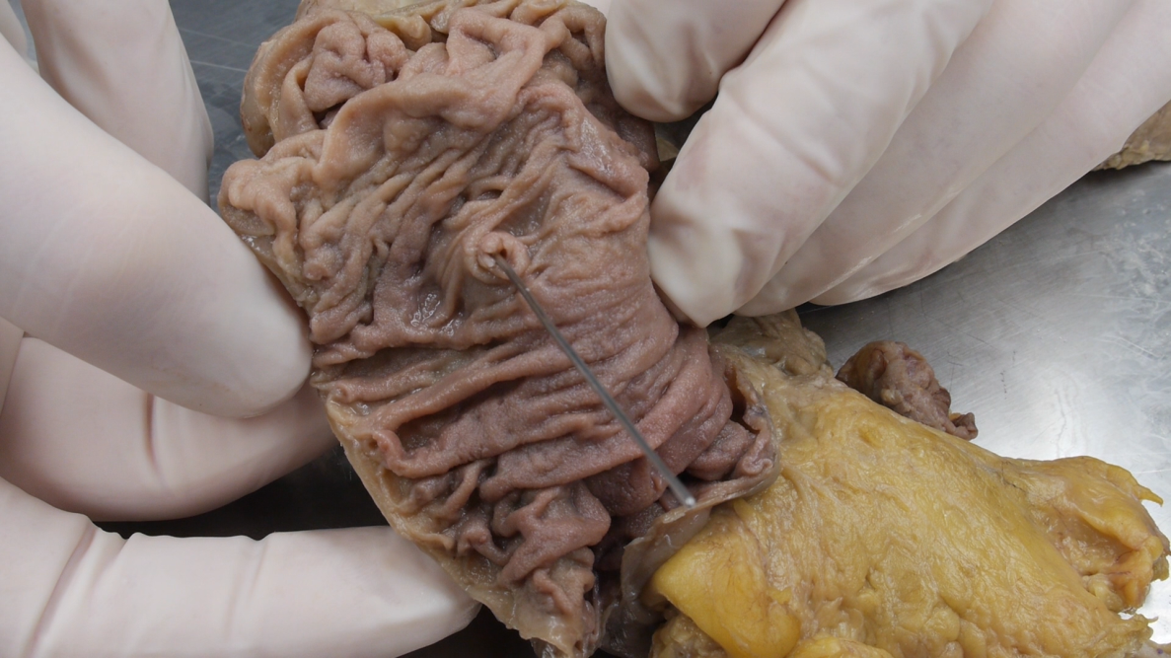

Figure 5: Open duodenum and the major duodenal papilla
Following the intestines, we arrive at the jejunum and the ileum. When you look at the first dissection picture (fig.1), you can see the jejunum and ileum as they normally lay in the body. Figure 6 shows they are attached to the mesentery. The mesentery contains fat and the blood vessels to the intestine.
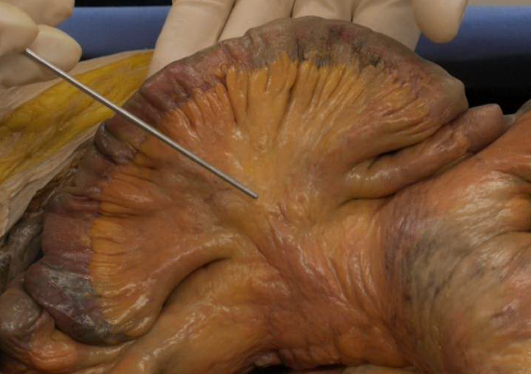

Figure 6. The mesentery of the small intestine
In the next dissection picture (figure 7), the jejunum has been taken out of the body. Opening the jejunum we once again find the circular folds or plicae.
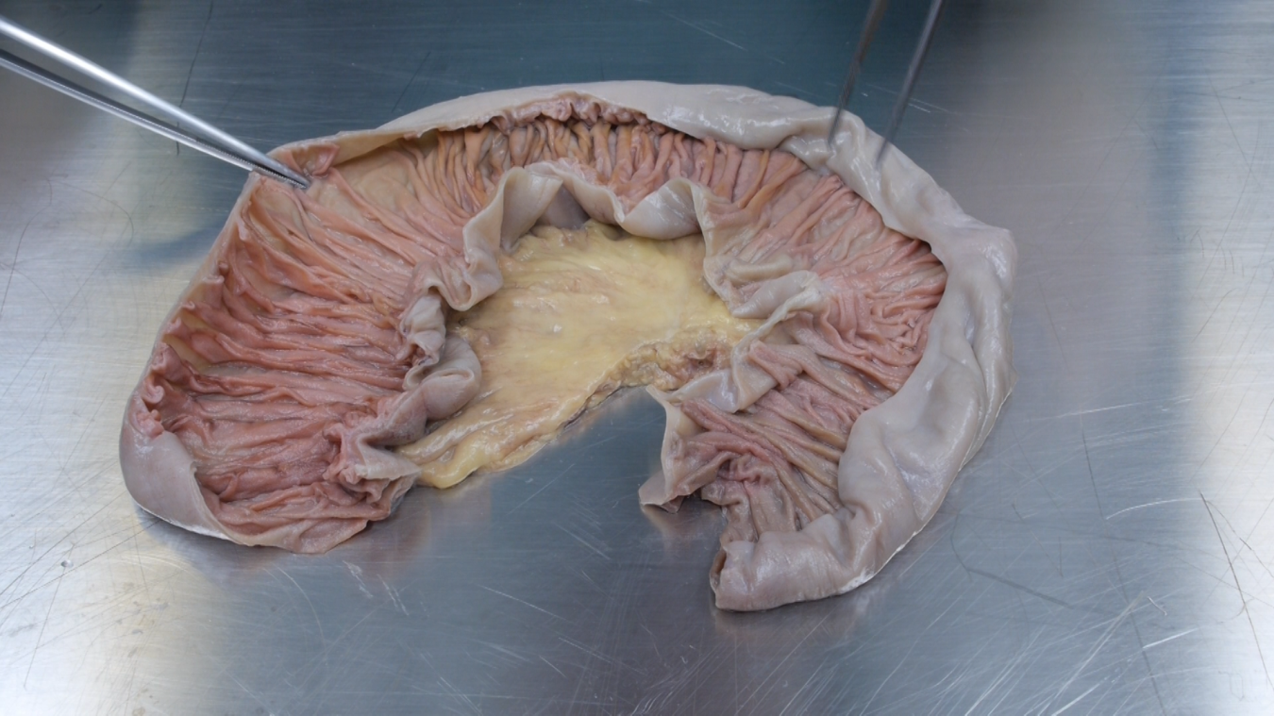

Figure 7: Open jejunum
Figure 8 shows a close up. Once more, notice the velvet-like appearance of the internal lining of these intestines. This results from the villi. One can compare it with a thick woven carpet. From some distance we are not able to see the individual hairs of the carpet, but the carpet surface as a whole has a velvet-like appearance. The folds together with the villi and the even smaller microvilli all serve to enlarge the absorptive surface of the intestines.
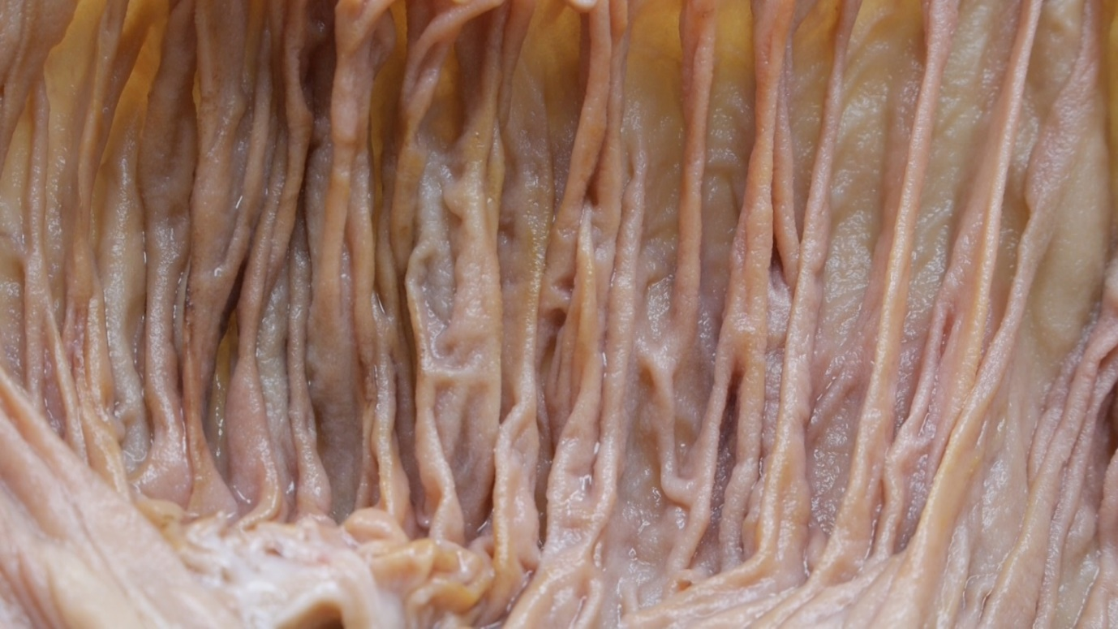

Figure 8 Close-up of the circular folds of the jejunum
Finally, the ileum. Figure 9 shows the last part of the ileum (terminal ileum) and the first part of the large intestine.
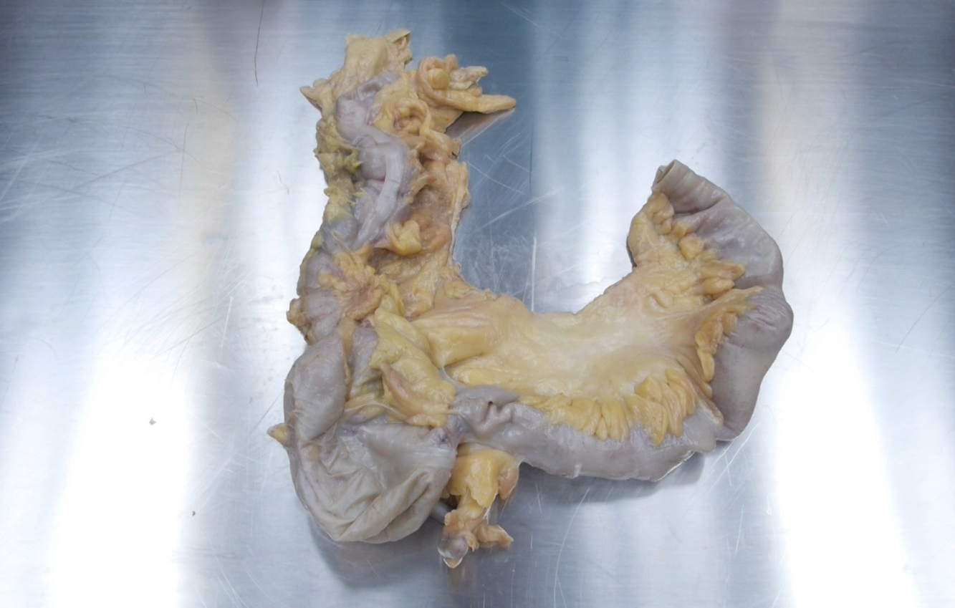

Figure 9: Terminal ileum and first part of the large intestine
In figure 10, the ileum is opened. In the ileum the plicae are lower and less numerous than in the jejunum. There is no sharp demarcation between the jejunum and the ileum. Rather, the characteristics change gradually when going from the beginning of the jejunum to the end of the ileum. You can see some of these characteristics. The jejunum is somewhat wider, the ileum somewhat narrower. Try to compare the two pictures!
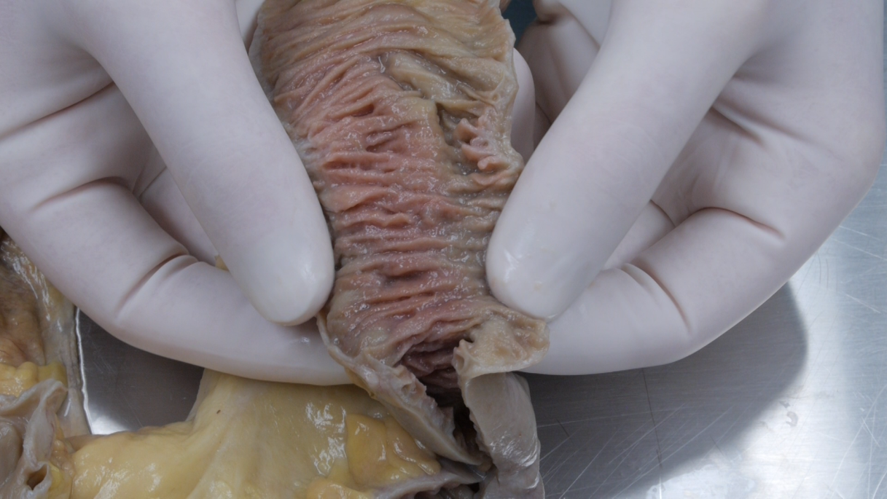

Figure 10: Opened ileum
Also, as you already saw, the folds are more numerous and higher in the jejunum, compared to the ileum. In the following dissection picture (figure 11) we show some more differences. In these specimens the blood vessels in the mesentery have been injected with dye. The vasa recta of the jejunum are longer and the arterial arcades are larger. In the ileum the vasa recta are shorter and the arterial arcades are smaller.

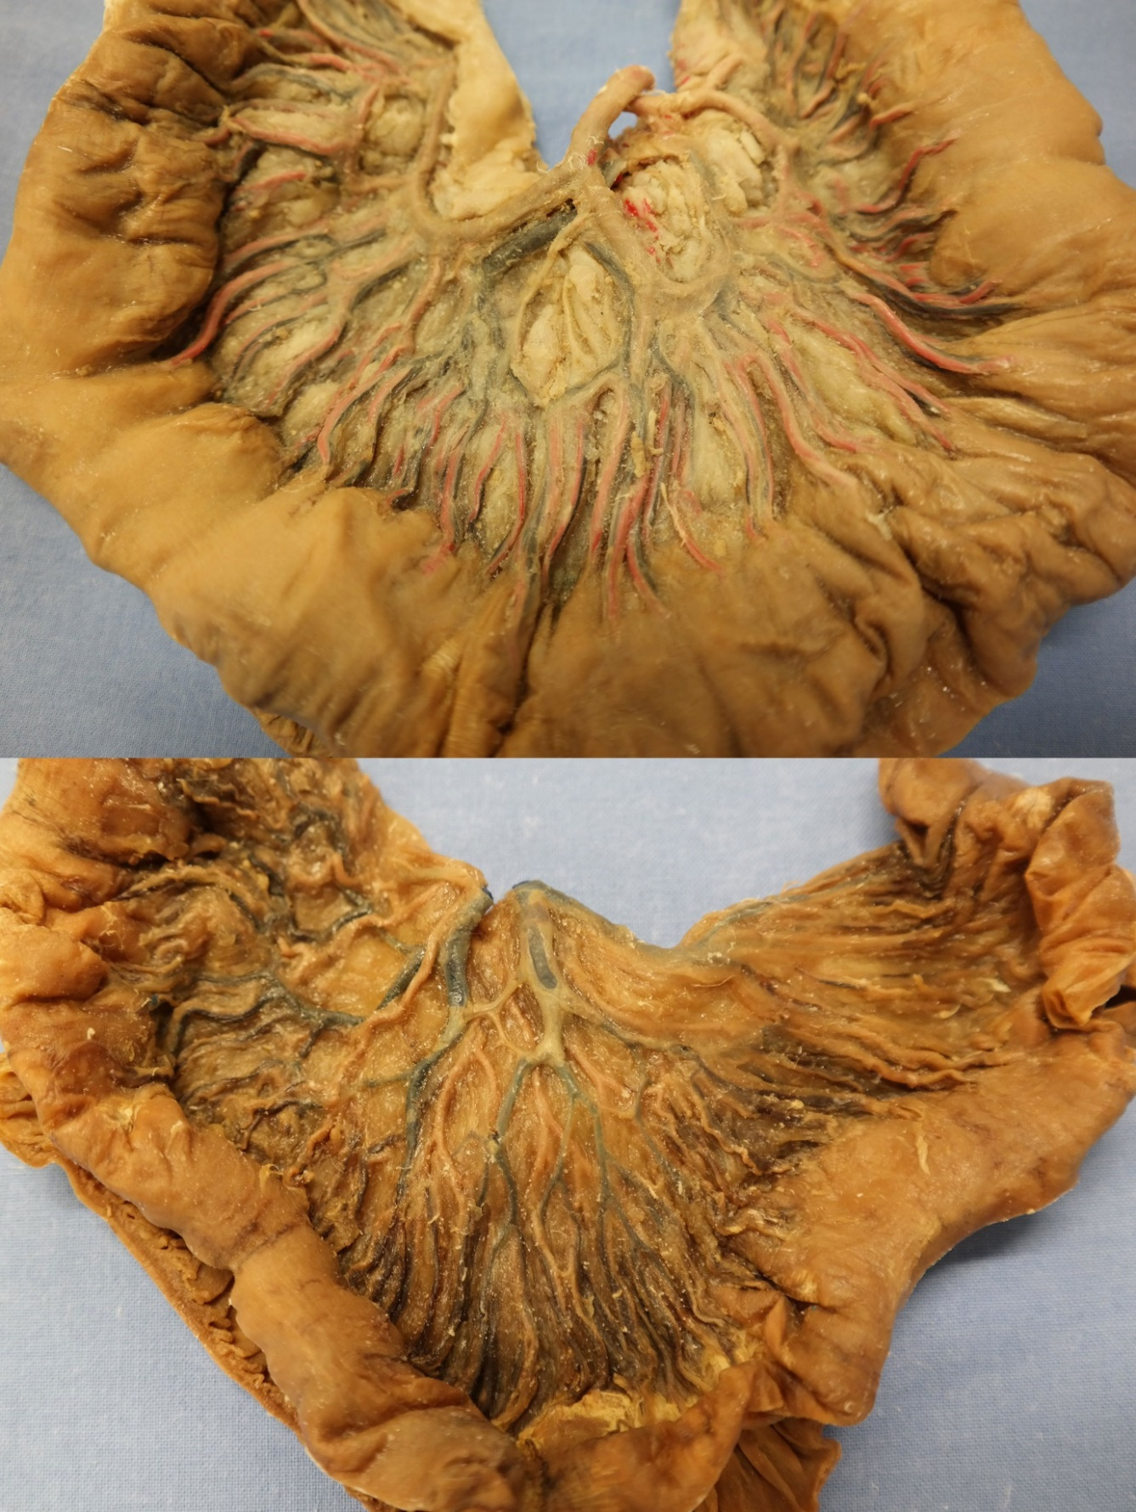Figure 11: Comparing vasa recta of jejunum and ileum
Basically, one might say that everything in the jejunum is larger and coarser in comparison to the ileum. The only exception is the fat in the mesentery; the ileum holds more fat in its mesentery than the jejunum does.
But all these differences may be difficult to discern in specific cases. At the end of the ileum, the ileum opens into the large intestine at the ileocaecal junction. This opening probably has a sphincteric function. More on that later, in the reader on ‘The large intestine’!
Don’t shy away from looking up terms when you don’t know them properly! There is still a lot to learn, and that is easier to do when you have a solid basic knowledge!

License:
Copyright: Dept. of Anatomy & Embryology, Leiden University Medical Center, Netherlands
This work is licensed under a Creative Commons Attribution-NonCommercial-ShareAlike 4.0 International license (CC-BY-NC-SA).


