Anatomy on the table - The large intestines
O.P. Gobée, Leiden University Medical Center, Netherlands. Originally created for MOOC 'Anatomy of the Abdomen and Pelvis; a journey from basis to clinic'. Slightly revised for separate publication Aug. 2021
MOOC: https://www.youtube.com/playlist?list=PLzugOrS2Z8opb0FR1eJMVcy8_p-wRMPET
In this reader we will talk about the large intestines in more detail. They comprise the caecum and appendix, the colon, and the rectum and anal canal. The rectum and anal canal are discussed separately.
First, the large intestines still in place in the body are shown.
Figure 1 shows the ileocaecal junction. At the ileocaecal junction the ileum enters the large intestine. The wide part of the large intestine that ends ‘blindly’ inferiorly to this junction is the caecum. The appendix is attached to its base.
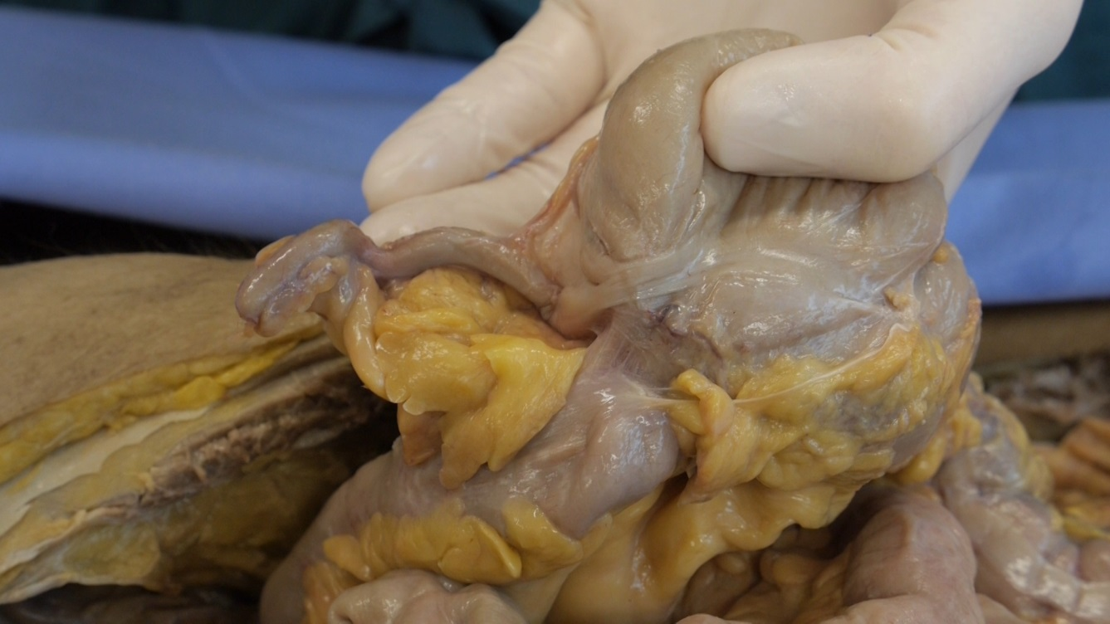

Figure 1: Ileocecal junction: ileum with caecum and appendix
Following the ileocaecal junction is the ascending colon (Figure 2). It is often somewhat hidden in the fat of the back wall, but is freed here to show it better.
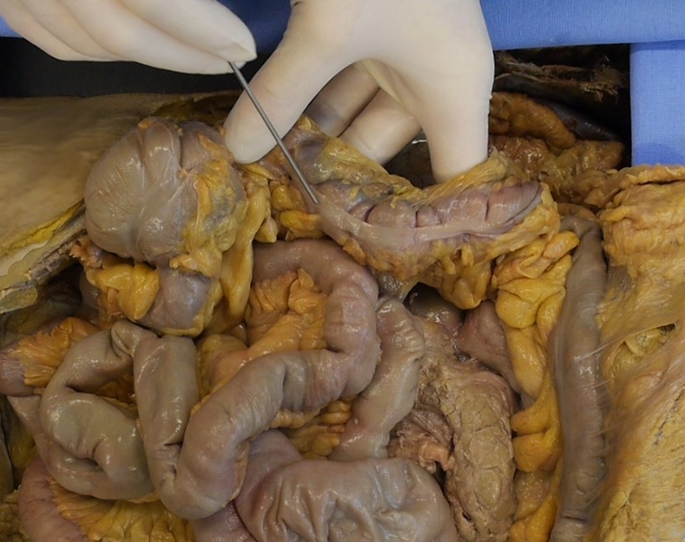

Figure 2: Ascending colon in the body
Next is the transverse colon, that crosses over the abdomen from right to left (figure 3). The diameter of the large intestines may vary between people. This large intestine is relatively thin.
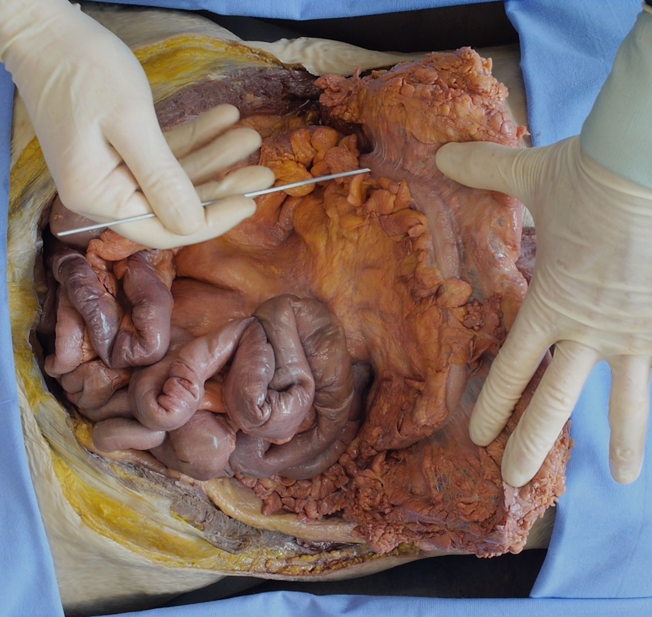

Figure 3: Transverse colon in the body
Next, figure 4 shows the descending colon. It is also hidden in the fat of the back wall.
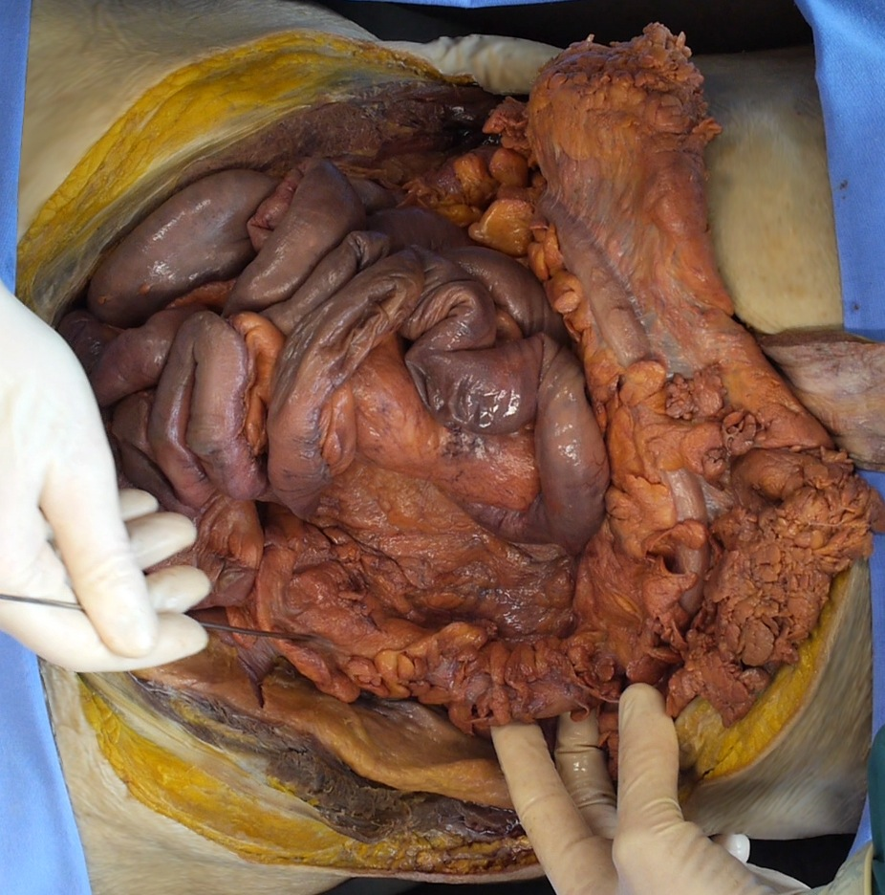

Figure 4: Descending colon in the body
Finally, figure 5 shows the sigmoid colon. It is mobile, as is demonstrated.
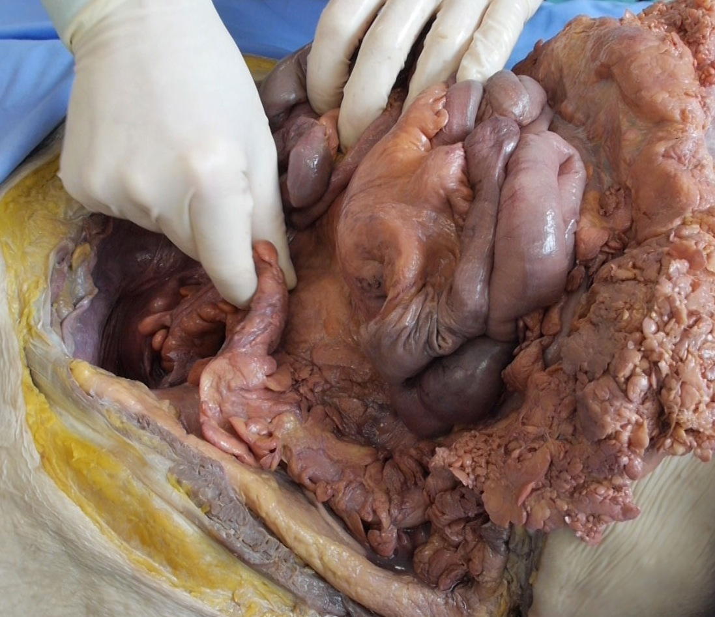

Figure 5: Sigmoid colon in the body
The rectum unfortunately runs out of view in the depth in the pelvis.
The colon has three characteristic features.
One of them are the so-called taeniae; these are longitudinal muscle bands that lie over the length of the colon (figure 6). They are thickened and condensed bands of the longitudinal muscle layer. They start at the base of the appendix and run all the way along the colon till the rectosigmoid junction. The taeniae contract the colon over its longitudinal axis, causing the colon to bulge out sac-wise. These sacs or bulges are called haustra. They are the second characteristic of the colon. You see them here on the ascending colon.
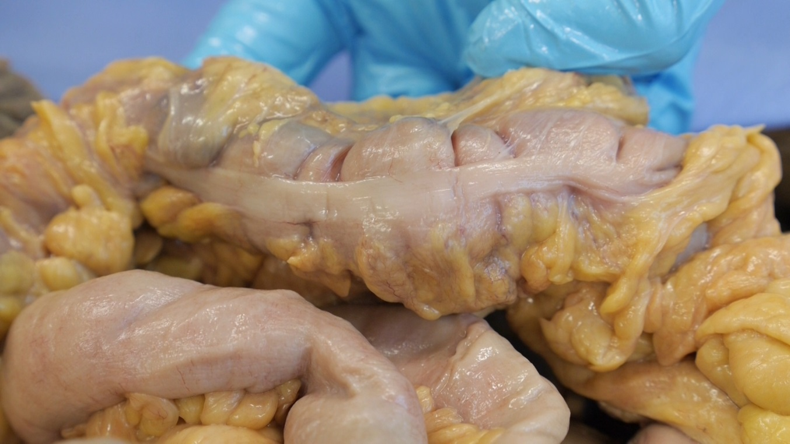

Figure 6: Taeniae and haustra
There are three taeniae, running parallel along the colon (figure 7). There is one omental taenia, that is named after the omental appendices attaching to it. You can read about omental appendices below. There is one called the mesocolic taenia, as the mesocolon attaches there. And last but not least, we can see one that is called free taenia, that does not attach to anything. Try to figure out which of the three taeniae is which.
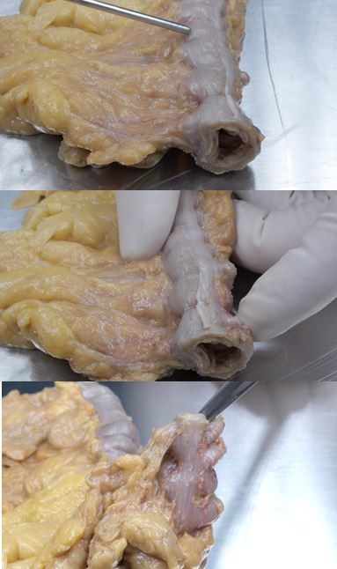

Figure 7: The three taeniae.
The last and third characteristic of the colon are the omental appendices. They are fatty projections hanging from the colon. They always catch the eye directly (figures 2 to 4), but their exact function is unknown. People hypothesized they might be protective, as soft and flexible cushions between the moving colon parts, or have an immunologic function, but as said, no one really knows. They may however get twisted or inflamed, causing abdominal pain.
Let's have a look inside the colon!
Figure 8 shows the ileocaecal junction from inside. The ileum enters the large intestine here. Despite this area has been investigated for the last four hundred years, there is still uncertainty as to the exact nature and function of this junction!
It was originally seen as a passive valve and named ileocaecal valve, based on its appearance in a postmortem body. When we look at it, it is bordered by two tissue folds that appear to form a valve. In living persons, it however has the appearance of a papilla, a protruding hill with a little opening in it. The muscle layer is thickened in this area, suggesting a sphincteric function. All mechanisms might also work in combination. The neutral name ileocecal junction therefore is probably the best.
It is thought that this ileocecal junction impedes reflux from the caecum backward into the ileum, to prevent the large amount of bacteria in the colon from entering the ileum, but also this function is not found in all investigations. But surgical removal of the junction does give digestive troubles... Combining all, the best assumption we can make, is that it seems to have some anti-reflux function.
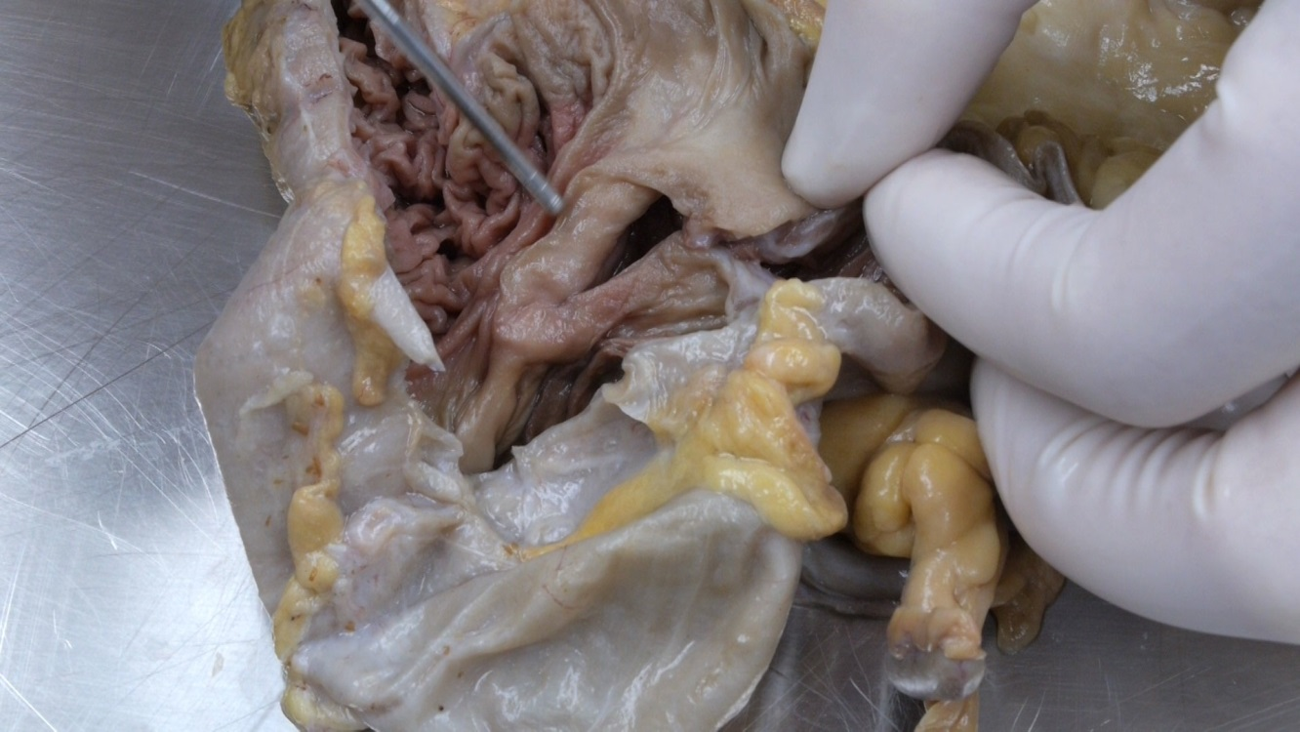

Figure 8: The iliocaecal junction from within.
In figure 9, you can see the inside of the cecum, a blind pouch of intestine. The appendix protrudes from it. We can see the opening of the appendix.
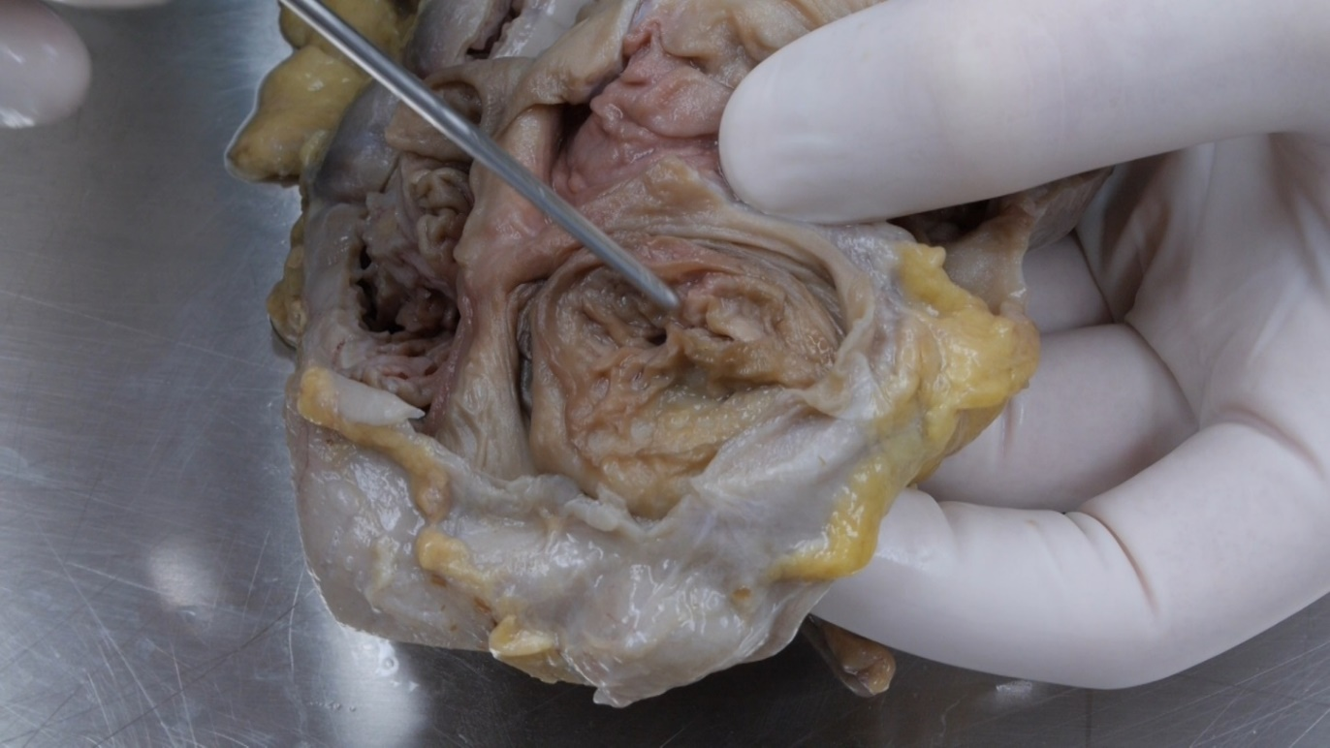

Figure 9: Inside caecum: the opening of the appendix
Because the semilunar folds were suboptimal in the dissection pictures, we will show them in pictures of a plastination specimen. This is a different method for preserving body parts. The tissue will probably look darker and more brown. In figure 10 you can see the semilunar folds of the colon. They result from the contraction of the ‎muscle layers in the colon wall. ‎ The 'holes' in the wall of the colon in fig. 10 are diverticula, they are pathological.

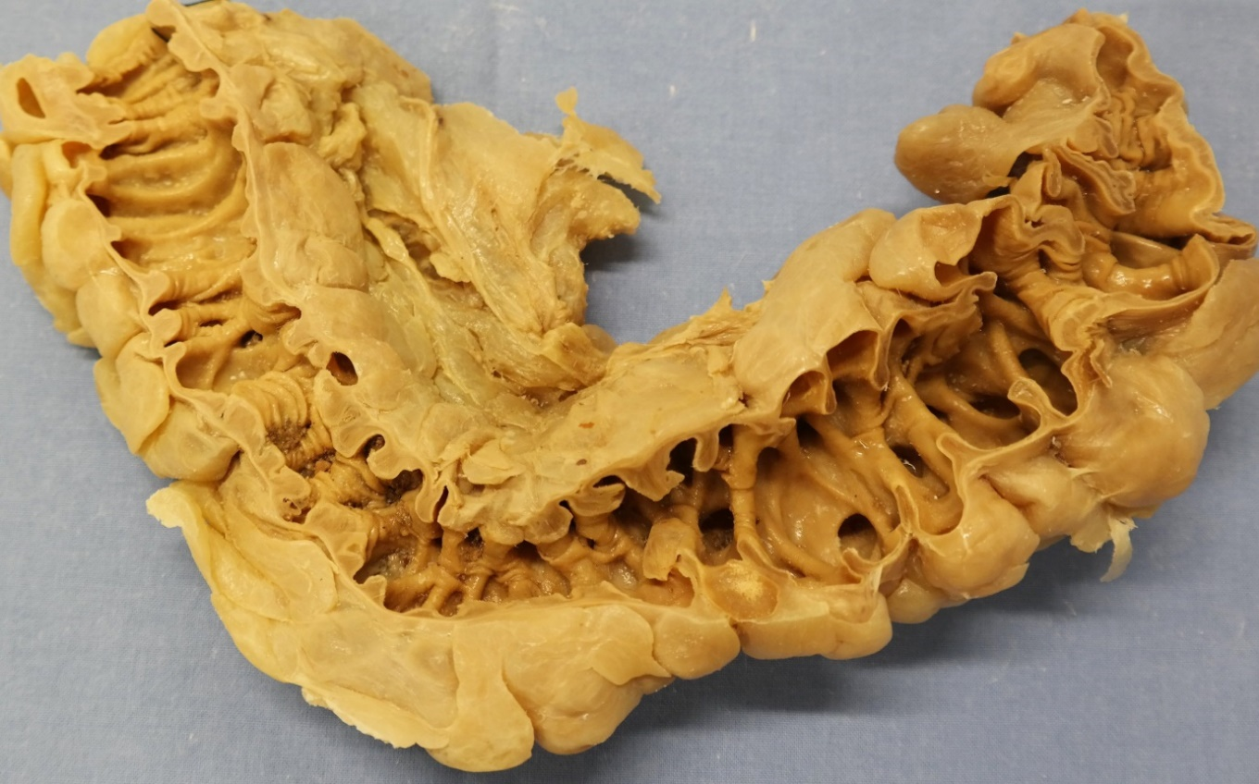Figure 10: Semilunar folds in plastination specimen
Concluding, in this reader we showed you the caecum, the appendix and the colon. Also we discussed the characteristics of the colon. Feel free to look things up if you don’t understand them completely yet!

License:
Copyright: Dept. of Anatomy & Embryology, Leiden University Medical Center, Netherlands
This work is licensed under a Creative Commons Attribution-NonCommercial-ShareAlike 4.0 International license (CC-BY-NC-SA).


