Anatomy on the table - The rectum and anus
O.P. Gobée, Leiden University Medical Center, Netherlands. Originally created for MOOC 'Anatomy of the Abdomen and Pelvis; a journey from basis to clinic'. Slightly revised for separate publication Aug. 2021
MOOC: https://www.youtube.com/playlist?list=PLzugOrS2Z8opb0FR1eJMVcy8_p-wRMPET
In this reader we will talk about the distal rectum and anus. Where the large intestine narrows at the end, is the junction from the rectum to the anal canal.
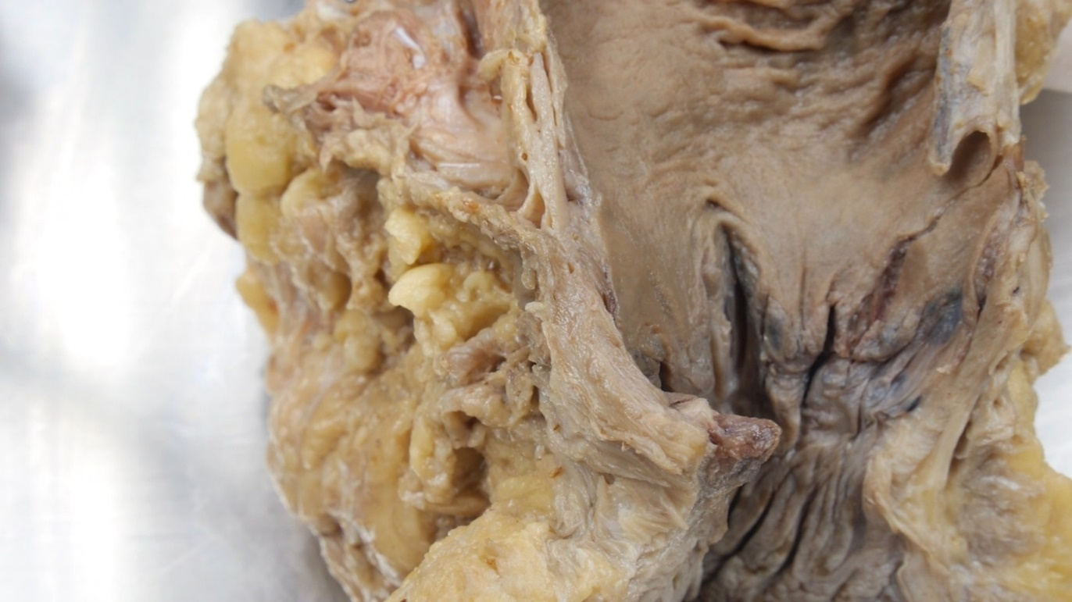

Figure 1: Pectinate line in the anal canal
Halfway the anal canal we can find a comb-shaped demarcation line, the pectinate or dentate line. It is the wavy border between light and dark tissue in fig. 1. and fig. 2. Superior to that line the intestine derives from the embryonic hindgut and the epithelium derives from endoderm. Inferior of that line the epithelium derives from ectoderm.
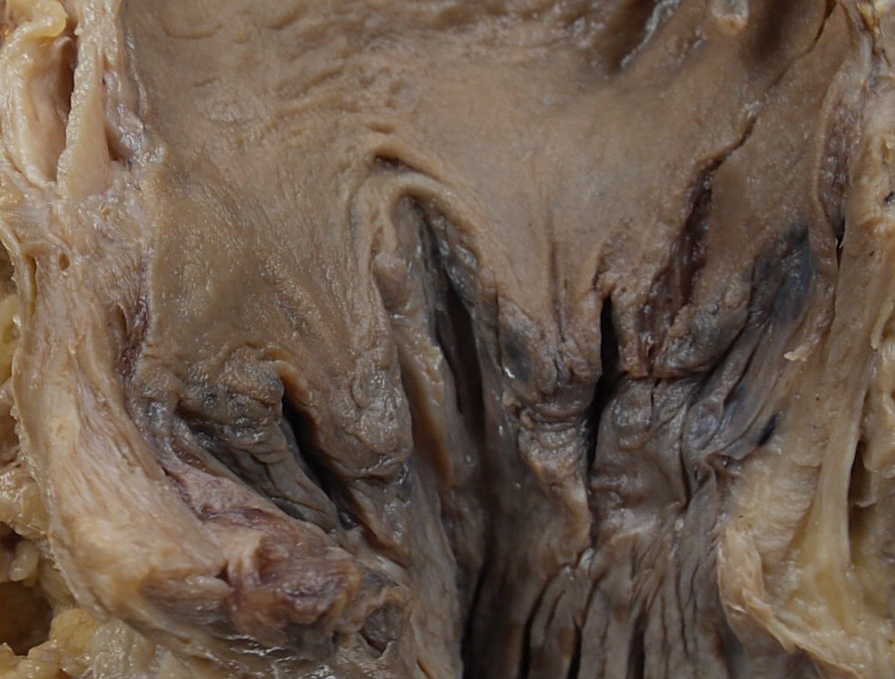

Figure 2: Pectinate line, close up
This makes this a clinically important demarcation line. Superior to the pectinate line the vasculature is derived from blood vessels of the gut, to be specific: branches and tributaries of the inferior mesenteric artery and vein. (If you do not remember where the inferior mesenteric and vein are, take some time to look them up!). Inferior of the pectinate line the vasculature is derived from the pelvic blood vessels, to be precise: branches and tributaries of the internal iliac arteries and veins. Thus superior of the pectinate line venous blood goes to the portal vein and ends up in the liver, whilst inferior of the pectinate line venous blood goes to the inferior vena cava, hence to the systemic circulation. This is an important distinction for instance for metastases from a rectal cancer. In the first case they will end up in the liver and in the second case in the lungs and bones. The distinction also influences the routing of drugs absorbed from rectal suppositories. In the first case they will pass through the liver and be metabolized there whilst in the second case they will enter the systemic circulation directly. However, this apparent clear distinction is clouded because the lower rectum has an extensive venous network that connects the both vascular areas. Thus blood from the lower rectum will most probably flow in both directions.
Closing of the anus is effected by two sphincters: an internal and an external anal sphincter. The internal sphincter is a thickening of the circular muscle layer of the upper part of the anal canal. It is involuntary and tonically closed most of the time to prevent leakage of fluid or flatus. It opens when the distal part of the rectum gets distended by faeces or flatus.
When the internal sphincter opens, one can still maintain continence by contracting the external sphincter. You can see the external sphincter in the dissection picture (figure 3). It lies at the lowest part of the levator ani muscles, that surrounds the anus. One can contract it voluntary.
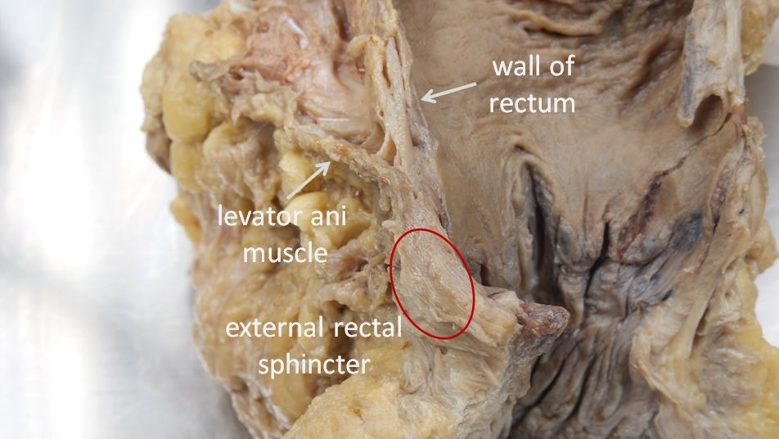

Figure 3: External sphincter is a thickening of the lower end of the levator ani muscle
In the vicinity of the anus are two venous plexi: the so-called internal and external rectal venous plexi. They are in fact anal plexi, but are called rectal. The internal rectal plexus (figure 4) lies in the submucosa of the anal canal. The submucosa is thickened here and the internal rectal venous plexus can swell with blood, thus forming anal cushions that contribute to closing the anal canal water- and gas-tight. These cushions can prolapse, then forming internal hemorrhoids.
The external rectal venous plexus lies at the outside of the anus, subcutaneously. External hemorrhoids are thromboses (blood clots) in the external rectal venous plexus.
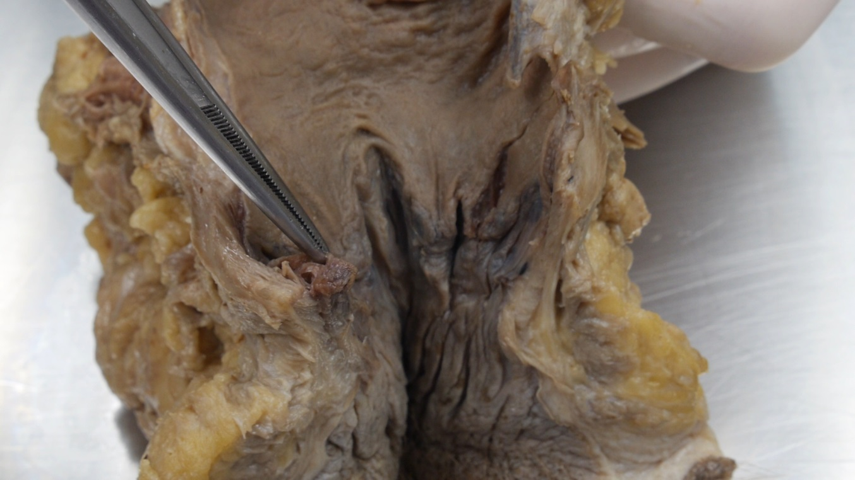

Figure 4: Internal rectal venous plexus
In this reader we discussed the two anal sphincters and the anal cushions that together provide continence for faeces and flatus. Also we discussed the importance of the pectinate line, that divides gut tissue from body wall tissue and thus forms the watershed line in vascularisation areas from respectively the gut and the body wall.

License:
Copyright: Dept. of Anatomy & Embryology, Leiden University Medical Center, Netherlands
This work is licensed under a Creative Commons Attribution-NonCommercial-ShareAlike 4.0 International license (CC-BY-NC-SA).


